**DevOps Updates**

**Imported Angularjs Project to Azure Repo:**

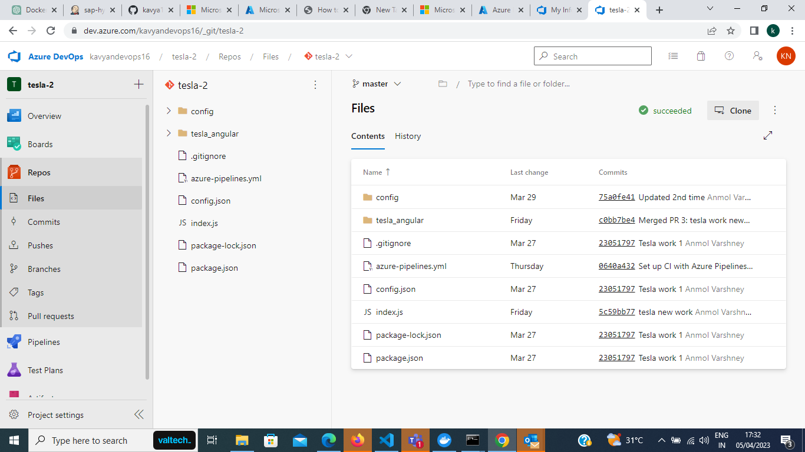

**Commits made to Repo**

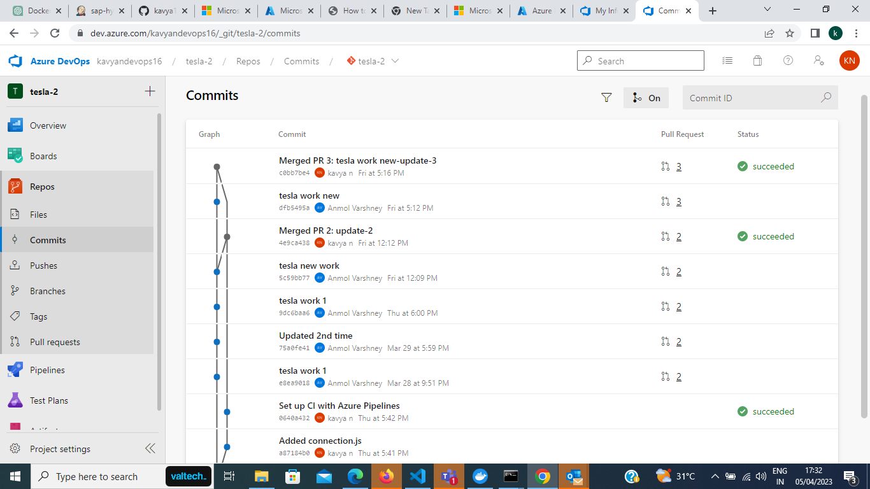

**Creating CI Pipeline for Angularjs Project**

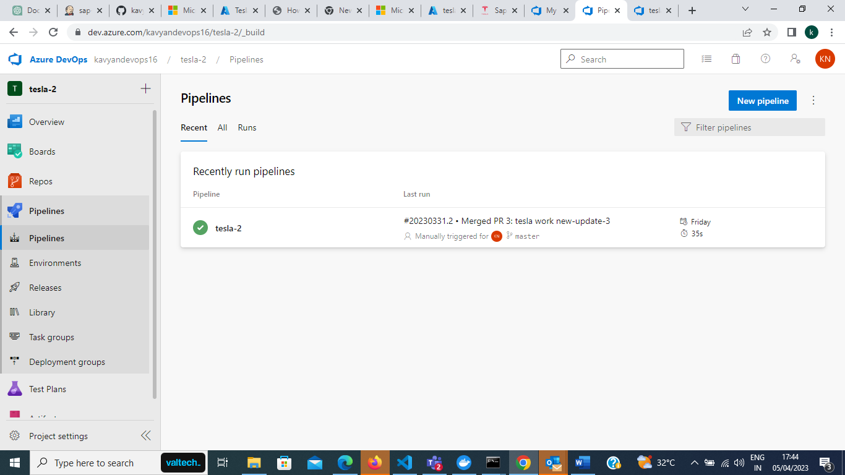

**Yaml File:**

trigger:

  - main

pool:

  vmImage: 'ubuntu-latest'

steps:

  - task: NodeTool@0

    inputs:

      versionSpec: '18.x'

    displayName: 'Install Node.js'

  - script: |

      npm install -g @angular/cli@latest

      npm install

    displayName: 'Install Angular CLI and build'

  - task: ArchiveFiles@2

    inputs:

      rootFolderOrFile: '$(Build.BinariesDirectory)'

      includeRootFolder: true

      archiveType: 'zip'

      archiveFile: '$(Build.ArtifactStagingDirectory)/$(Build.BuildId).zip'

      replaceExistingArchive: true

  - task: PublishBuildArtifacts@1

    inputs:

      artifactName: 'dist'

      pathToPublish: '$(Build.ArtifactStagingDirectory)/$(Build.BuildId).zip'

    displayName: 'Publish build artifacts'

**Creating Web app + Database in Resource Group named new2**

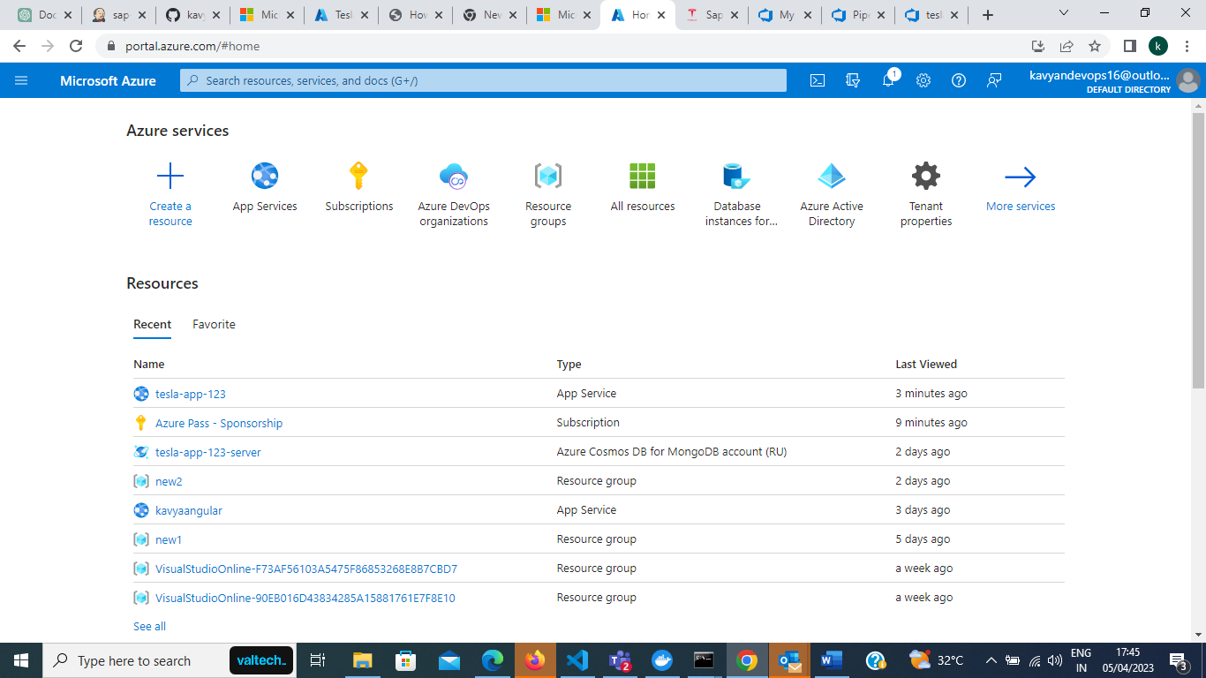

**Resource Group new2 contains the required resources**.

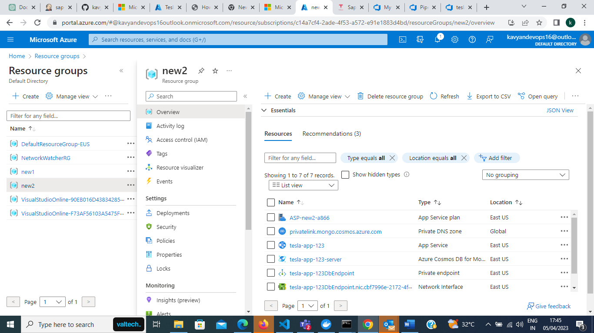

**App Service is named with tesla-app-123**

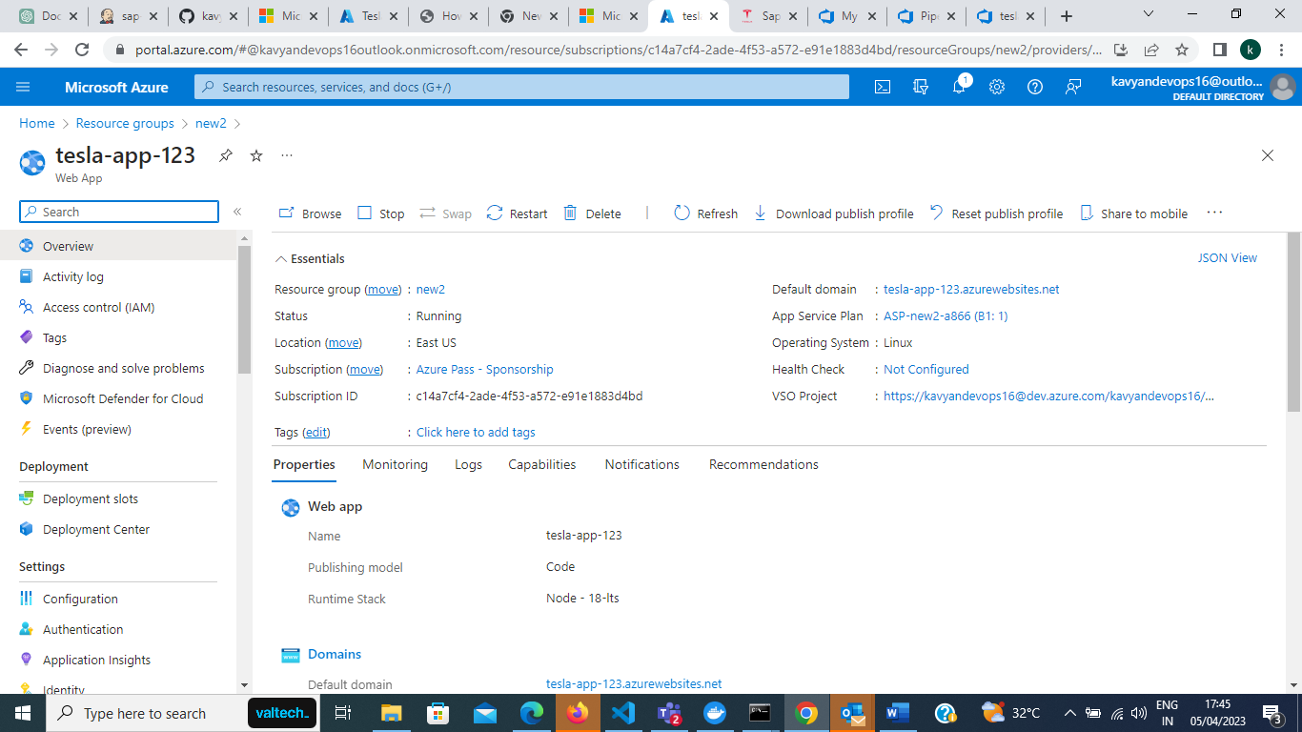

**Deployment done by Azure Repos Source Control**

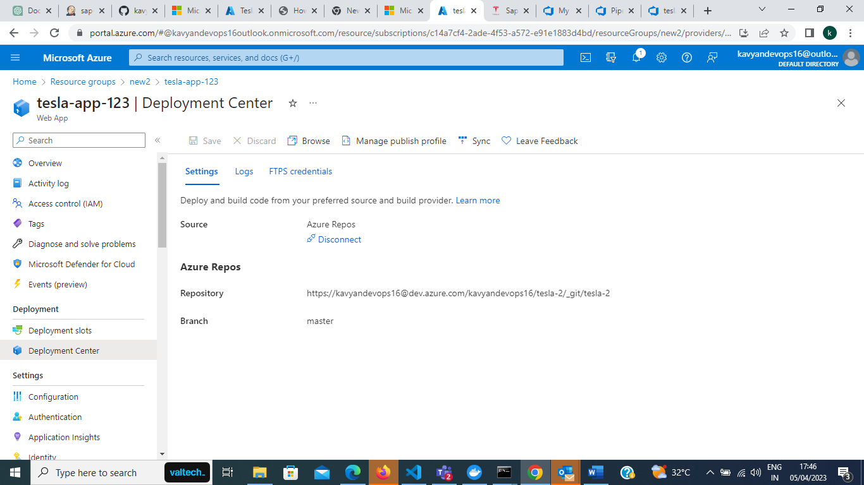

**Configuration**

~~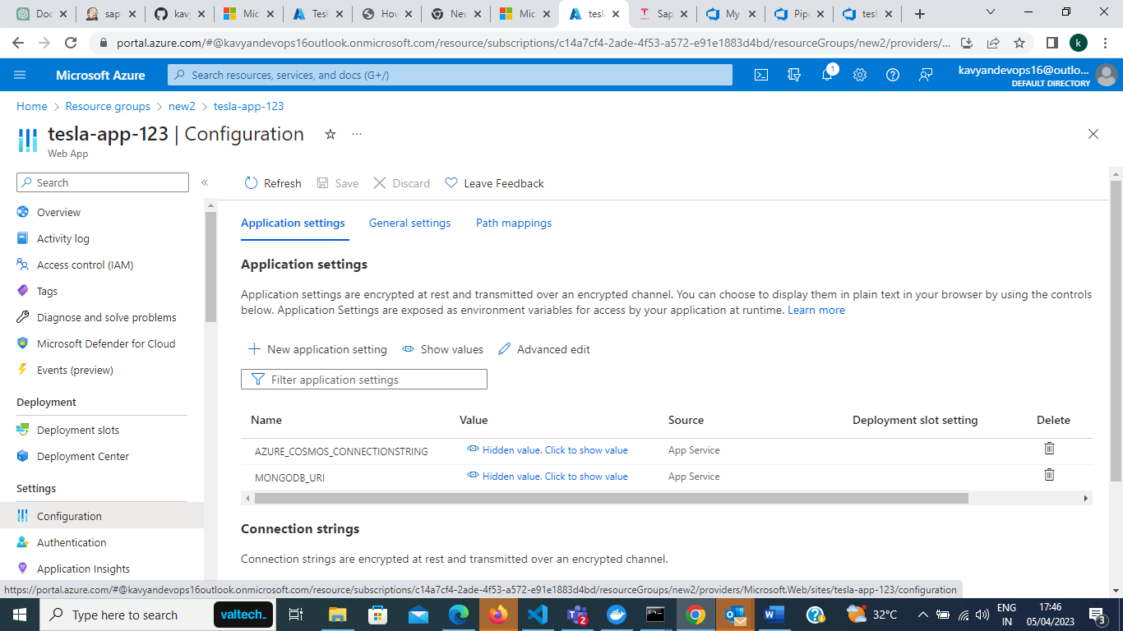~~

**App Service Link:**

<https://tesla-app-123.azurewebsites.net/>

**Final output when browsed.**

